

**MURANG’A UNIVERSITY OF TECHNOLOGY**

**IEBC VOTER REGISTRATION AND VOTING SYSTEM**

**BY**

**VICTOR MUGO NDEGWA**

**SC200/5064/2018**

A report submitted to the School of Computing and Information Technology in partial fulfillment of the requirement for degree of Bachelors of Science in Computer Science.

JULY 2022

**DECLARATION**

I Victor Mugo Ndegwa, Registration number SC200/5064/2018 declare that everything in this document is my own original work and the contents of this document is original and has not been presented in any other institution for the award of degree in computer science.

**STUDENT CONFIRMATION**

VICTOR MUGO NDEGWA SC200/5064/2018

SIGNATURE…………………... DATE………………

**SUPERVISOR CONFIRMATION**

NAME………………………………………………

SIGNATURE………………...DATE………………...

**ACKNOWLEDGMENT**

I would like to that everybody especially my supervisors, Ms. Evelyn Nekesa for the support I received during my research and survey for the generation of the proposal and Ms. Millicent my project supervisor. I am grateful for the support from all institutions and relevant authorities that I involved in my research for the proposal and final project.

I also thank The Almighty for giving me the energy to carry out this project.

**Abstract**

During the previous Voter Registration, the Independent, Electoral and Boundaries Commission (IEBC) used a vast number of resources and various computer devices, components and software that are old and hectic to train and use for new voter registration.

In this era of great technological advancements, a day-to-day use smart-phone can be programmed to collect all the necessary data a new voter is required to provide to the commission for them to be registered as a new voter.

This project highlights the designing of a mobile system that can be easily used by a new voter to register. This is because a smart-phone contains various data collection devices like personal details, camera and fingerprint scanner. All this data can also be submitted in real time to the central server or database.

Catalog

Chapter one: Introduction 1

1.1 Background of study 1

1.2 Statement of problem. 1

1.3 Study objectives 2

1.3.1 Main objective 2

1.3.2 specific objectives 2

1.4 Research question 2

1.5 Significance 2

1.6 Limitations 3

1.7 Assumptions 3

Chapter Two: Literature Review 4

Introduction 4

System one: BVR 4

System two: Medical Insurance ID 6

These systems are designed and founded by the respective health insurance providers to identify clients at the various hospital branches. 6

Chapter three: Research Methodology 7

3.1 Introduction 7

3.2 Research design 7

3.3 Population and sampling 8

3.4 Data Collection Method 10

3.5 System Design 11

3.6 System Analysis, Design and Development 13

3.6.1 System Development Methodology 13

3.6.2 Data processing and analytics 16

3.6.3 Development Tools and materials 16

1. Software specifications 16

2. Hardware specifications 16

3.7 Ethical Issues 17

Chapter Four: System Design, Implementation and Testing 18

4.1 Introduction. 18

4.2 System Design. 18

4.2.1 Functional requirement 18

4.2.2 Non-functional requirements 18

4.3 Implementation 19

4.3.1 Authentication Logic. 19

4.3.2 Admin Dashboard 20

4.3.3 Voter Dashboard 21

4.4 Coding Details and Code Efficiency 21

4.5 Testing 22

4.5.1 Unit Testing 22

4.5.2 Integration Testing 22

4.5.3 Usability Testing 22

Chapter Five: Results and Discussion 23

5.1 Test Report 23

5.2.1 Interface 23

Chapter Six: Conclusions 25

6.1 Summary of The Findings 25

6.2 Conclusions and Future Works 25

6.3 Recommendation. 25

References 26

APPENDICES 27

Appendix I: Grantt Chart 27

Appendix II: Budget 27

# Chapter one: Introduction

## 1.1 Background of study

During the recently concluded Enhanced Voter Registration exercise conducted by the IEBC, a new adult who wishes to register as a voter would visit a strategic voter registration desk or visit the Constituency office with their Identity document. These strategic registrations desks were mobile and worked during office working hours. This means that they would be somewhere else almost every new day. There was also a lot of paper-work involved in the process which is almost never reviewed later.

This system aims at creating a registration website to enable new voters, who are especially the younger and own smart phones can easily register as a voter through an application on their mobile device that collects the information required for registration, which can be accessed from anywhere and data sent through the internet. Voters who are registered but wish to change their particulars and/or registration center can do so on the platform.

## 1.2 Statement of problem.

Lots of resources and time is spent by the commission, hiring registration clerks who traverse through the various parts of a Constituency over a period of time, about a month. The prospective voters also have to look for those registration clerks within office hours, which might inconvenience them since they might also be working or in school.

This also applies to already registered voters who wish to change their voting particulars and might be committed elsewhere.

The main problem is access and heavy use of resources which could be summed as inefficiency.

## 1.3 Study objectives

### 1.3.1 Main objective

To develop a web-based platform for prospective voters to register as voters in the IEBC and provide all the data required.

### 1.3.2 specific objectives

1. To study existing systems

2.To study the online registration protocol

3.To design a platform for data collection and submission.

4.To design an easy-to-use platform for online registration

## 1.4 Research question

1.Will the system allow for easier online registration?

2.Will the system user interface be friendly to users?

3.Will the system be feasible to the currently available technology?

4.Will system efficiently capture all the required data?

## 1.5 Significance

This system will ease time taken in search of registration venue and the registration clerks, including time wasted waiting on the queue to be served.

This system will also reduce the number of resources used by the commission to procure the BVR (Biometric Voter Registration) computers and peripherals, and also the resources used to hire and train temporary registration clerks and all the other logistics involved.

This system will ease access to easy and fast voter registration process without having to physically presenting themselves before a registration desk.

## 1.6 Limitations

The system will have the following limitations:

1.The system will help voters with training from the platform first.

2.The system will not work offline.

3. The system only works with smartphones

4. The system does not currently capture biometrics.

## 1.7 Assumptions

1.The system will work conveniently and help voters access registration without physical presentation, from the convenience of their phone.

1. Voters will be able to use the platform with only the little instructions provided on the platform.
2. Voters will provide the correct information without compromise and complete the whole process of registration.

# Chapter Two: Literature Review

## Introduction

This chapter outlines the currently existing voter registration process, the customized software that is used, the logistics involved in the whole process, the data submission levels and other various government registration platforms, especially those that are online.

This chapter discusses each system into details by identifying the period in which the platform was founded and acknowledge the founders, outline reason(s) as to why the platform was built and later strengths and weaknesses of each platform.

### System one: BVR

This system was founded in the year 2012 by the Kenyan National Government, through the IEBC. It was designed and implemented by the French company SAFRAN MORPHO, to offer mass voter registration services to Kenyans.

The components of the BVR were also procured from the same company, for easy integration into the software and compatibility without any further configurations.

Every voter in Kenya was registered through that system in 2012 during the mass voter registration period, in a bid by the government to digitize the voter register and ensure equality and fairness during the voting process.

The primary component is a 2010 model Dell E6320 laptop which can be charged and store charge in its external battery.

The next device is a fingerprint scanner, connected to the laptop via USB in the laptop’s first port.

The rest of the devices are connected through a USB hub which is connected to the second of the laptop’s two USB ports.

These other devices are a 1080p (pixels) web camera to take the voters’ portraits, a flash disk to continuously save the registration details as a continuous backup, and finally a backup flash disk to export all the day’s registration data in the evening.

**Advantages**

The BVR has specific components for data capturing.

It has customized operating system and registration software for registration purposes only.

The registration personnel are thoroughly trained and equipped with the skills necessary for the whole registration process to reduce error occurrence or poor data collection.

This system has various backup stages thus difficult to lose data.

**Disadvantages**

The system components are for registration purposes only thus used rarely which is under-utilization of resources.

The system uses Windows XP as its base operating system which is outdated and offers only the specific work of capturing voter details.

This registration process also involves lots of paperwork which is unnecessary and could be eliminated. It only acts as a reference and is not used again. It could also be tedious in case one is trying to look for a specific individual registration form.

### System two: Medical Insurance ID

### These systems are designed and founded by the respective health insurance providers to identify clients at the various hospital branches.

This system allows creation of medical profiles which are made available in real time across any medical branch where the insurance information, especially on resources to use it and the available limit, is made accessible in real time; and the patient identity is confirmed through fingerprint scanning.

This app allows quick access to vital information of the patient even during an emergency.

This system allows access to final information such allergies, blood pressure, blood type, medical contacts, available insurance balance to provide services to the patient.

**Advantages**

The system is very responsive and give immediate feedback to the hospital.

The app is easily availing all the relevant information about the system when needed.

The system is very helpful in case of emergency.

**Disadvantages**

The system is only available by the use of a computer and other peripherals like fingerprint scanners.

The system must have a reliable central server to store all the data and process all the request and does not have room to fail in case of an emergency.

The system does not work offline.

# Chapter three: Research Methodology

## 3.1 Introduction

Research methodology is a chapter of a research that describes research methods, approaches and designs in detail highlighting those used throughout the study, justifying the choice made through describing advantages and disadvantages of each approach and design taking into account their practical applicability to the research. This chapter outlines research design, population and sampling, data collection and materials, system development methodology, system design and data processing.

## 3.2 Research design

The research design is the conceptual framework within which the research is carried out. According to Nery M. et al., (2019), a descriptive design is a sort of study design that tries to collect data in order to characterize a phenomena, situation, or population in a systematic manner. More precisely, it assists in determining the what, when, where, and how of the research challenge, rather than the why.

To explore the variables in question, the descriptive technique of research might involve the use of a variety of research methods. It mostly uses quantitative data; however qualitative data is occasionally employed for descriptive purposes.

It is vital to stress that, unlike experimental research, the researcher does not control or influence any factors in descriptive research. The variables are just recognized, observed, and measured in this case.

**Advantages of descriptive research**

Descriptive research has multiple methods of data collection that can be used including the case study method, observational method, and the survey method.

Descriptive research design is fast and cost effective as it often employs the use of surveys, data can be collected from a very large sample size in a quick and cost-effective way.

Descriptive research design is comprehensive as it employs the use of quantitative and qualitative research in amalgamation, providing a more holistic understanding of the research topic.

Descriptive research has external validity. Results obtained through the descriptive method of research often have high external validity as research is conducted in the respondent’s manual environment and no variables are manipulated.

**Disadvantages of descriptive research design**

Descriptive research design cannot test or verify the research problem as the data collected does not help explain the cause of the phenomena being studied.

Descriptive research design lacks reliability as research problem is not formulated well, then the data collected may not be entirely reliable. This also makes it more tedious to carry out a credible investigation.

Risk of untrue responses: descriptive research relies on the responses of people, especially when conducted using surveys. There may be instances when people provide false responses and this will compromise the validity of the data collected and ultimately the results of the research.

Risk of sampling error: the descriptive method of research generally employs random sampling while selecting a sample group. The randomness may lead to sampling error if the sample group isn’t representative of the larger population. Sampling error would lead to unreliable and inaccurate results.

## 3.3 Population and sampling

Population is a complete set of elements (persons or objects) that possess some common characteristic defined by the sampling criteria established by the researcher. A sample is defined as a smaller set of data that a researcher chooses or selects from a larger population by using a predefined selection method.

The target population of this research includes buyers and sellers of real estate who are either at a specific location or across the globe. Sellers of these properties includes individuals or companies. In this study, the accessible population is any person interested in either buying and selling of real estate products and is of eighteen years and above.

**Advantages of population and sampling**

It lacks bias because individuals who make up the subset of the larger group are chosen at random, each individual in the large population set has the same probability of being selected. This creates, in most cases, a balanced subset that carries the greatest potential for representing the larger group as a whole.

It is simple. As its name implies, producing a simple random sample is much less complicated than other methods, such as stratified random sampling. As mentioned, individuals in the subset are selected randomly and there are no additional steps.

**Disadvantages of population and sampling**

It is time consuming. When a full list of a larger population is not available, individuals attempting to conduct simple random sampling must gather information from other sources. If publicly available, smaller subset lists can be used to recreate a full list of a larger population, but this strategy takes time to complete. Organizations that keep data on students, employees, and individual consumers often impose lengthy retrieval processes that can stall a researcher's ability to obtain the most accurate information on the entire population set.

It is costly. To gather information from various sources, the process may cost a company or individual a substantial amount of capital. Retrieving a full list of a population or smaller subset lists from a third-party data provider may require payment each time data is provided. If the sample is not large enough to represent the views of the entire population during the first round of simple random sampling, purchasing additional lists or databases to avoid a sampling error can be prohibitive.

## 3.4 Data Collection Method

The researcher will use a questionnaire as the primary data collection technique to gather and acquire data from the prospective users of the system.

A questionnaire is a research instrument consisting of a series of questions for the purpose of gathering specific information from respondents.

In this scenario, considering the guidelines provided by the Ministry of Health concerning COVID-19 epidemic, questionnaire is prepared through a Google form and is sent to the respondents via a link.

**Advantages of questionnaire**

Questionnaire is cost efficient. questionnaires are one of the most affordable ways to gather quantitative data. Especially self-administered questionnaires, where you don’t have to hire surveyors to perform face-to-face interviews, are a cost-efficient way to quickly collect massive amounts of information from a large number of people in a relatively short period of time.

Questionnaire is practical way to gather. It can be targeted to groups of your choosing and managed in various ways. You can pick and choose the questions asked as well as the format (open-ended or multiple choice). It offers a way to gather vast amounts of data on any subject. It can be used in a wide variety of ways, like customer feedback.

Questionnaires allows researcher to gather information from a large audience. Online, you can literally distribute your questions to anyone, anywhere in the world (provided they have an internet connection). All you have to do is send them a link to your survey page. And you don’t even need to do this manually. This could be done through an automated email in your customer on boarding or lead nurturing campaigns.

**Disadvantages of questionnaire**

Dishonest answers: while there are many positives to questionnaires, dishonesty can be an issue. Respondents may not be 100% truthful with their answers. This can happen for a variety of reasons, including social desirability bias and attempting to protect privacy. Stop dishonesty in its tracks by assuring respondents that their privacy is valued and that the process prevents personal identification.

Unanswered questions: when using questionnaires, there is a chance that some questions will be ignored or left unanswered. If questions are not required, there is always that risk they won’t be answered. Online questionnaires offer a simple solution to this issue: make answering the question required. Otherwise, make your survey short and your questions uncomplicated and you will avoid question skipping and get better completion rates.

Hard to convey feelings and emotions: questionnaire cannot fully capture emotional responses or feelings of respondents. Without administering the questionnaire face-to-face, there is no way to observe facial expression, reactions or body language. Without these subtleties, useful data can go unnoticed. Don’t get stuck trying to interpret emotion in data, instead go for a Like scale, the response scale that often uses a rating scale from “slightly agree” to “strongly disagree.” This allows for strength and assertion in responses rather than multiple choice.

## 3.5 System Design

Systems design is the process of defining elements of a system like modules, architecture, components and their interfaces and data for a system based on the specified requirements. It is the process of defining, developing and designing systems which satisfies the specific needs and requirements of a business or organization.

Voter profile Creation Portal

Real Voting Portal

Votes Tallying Portal

Voter Viewing Portal

IEBC Voter Data Portal

ICT Admin Portal

RO/DRO portal

*Figure 1: Use case Diagram*

The above figure shows all the system users who play different critical roles in the system. The users include:

1. Voters: the voters are required to sign up in the system and the system on the other hand is required to verify them through the identity document number that will already be in the system. Voter profile creation portal is the first step for the voter and allows for creation of a voter profile.

After the system confirms their identity document is valid and has not been used to register anyone, the voter proceeds to read the instructions and enter the data collection portal to upload their particulars.

Already registered voters can log in to the portal to change their alphanumeric particulars and/or polling station of their choice.

The voters can also vote for the various elective positions, one choice per category is allowed and once a voter votes once the system does not allow them to vote again.

1. The ICT and Returning officer (RO/DRO) also have a portal to validate the registrations and/or change of particulars of an existing voter so it can go through to the central database. They can also be able to access the registration and voting analysis and know the percentage of their registration versus their target population.

## 3.6 System Analysis, Design and Development

### 3.6.1 System Development Methodology

The researcher employs waterfall methodology in development of the proposed system. In waterfall, each development process that flows like a waterfall through all phases of a project (analysis, design, development, and testing, for example), with each phase completely wrapping up before the next phase begins.

The following illustration is a representation of the different phases of the Waterfall Model:

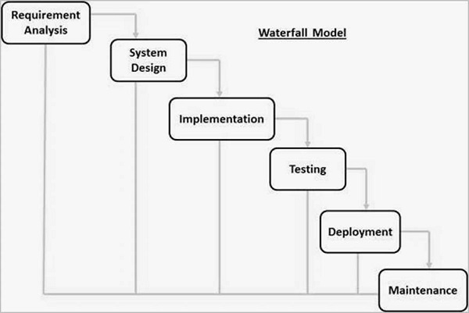

The sequential phases in Waterfall model are:

1. Requirement Gathering and analysis− All possible requirements of the system to be developed are captured in this phase and documented in a requirement specification document.
2. System Design− The requirement specifications from first phase are studied in this phase and the system design is prepared. This system design helps in specifying hardware and system requirements and helps in defining the overall system architecture.
3. Implementation− With inputs from the system design, the system is first developed in small programs called units, which are integrated in the next phase. Each unit is developed and tested for its functionality, which is referred to as Unit Testing.
4. Integration and Testing− All the units developed in the implementation phase are integrated into a system after testing of each unit. Post integration the entire system is tested for any faults and failures
5. Deployment of system− Once the functional and non-functional testing is done; the product is deployed in the customer environment or released into the market.
6. Maintenance− There are some issues which come up in the client environment. To fix those issues, patches are released. Also, to enhance the product some better versions are released. Maintenance is done to deliver these changes in the customer environment.

All these phases are cascaded to each other in which progress is seen as flowing steadily downwards (like a waterfall) through the phases. The next phase is started only after the defined set of goals are achieved for previous phase and it is signed off, so the name "Waterfall Model". In this model, phases do not overlap.

**Advantages of waterfall methodology**

Waterfall uses clear structure. When compared with other methodologies.

Waterfall focuses most on a clear, defined set of steps. Its structure is simple.

Waterfall determines the end goal clearly. One of the defining steps of waterfall is committing to an end product, goal, or deliverable at the beginning, and teams should avoid deviating from that commitment. For small projects where goals are clear, this step makes your team aware of the overall goal from the beginning, with less potential for getting lost in the details as the project moves forward.

Waterfall transfers information well. Its approach is highly methodical, so it should come as no surprise that the methodology emphasizes a clean transfer of information at each step. When applied in a software setting, every new step involves a new group of people, and though that might not be the case at your company, you still should aim to document information throughout a project’s life cycle. Whether you’re passing projects off at each step or experience unexpected personnel changes, Waterfall prioritizes accessible information so new additions to the team can get up to speed quickly if needed.

**Disadvantages of waterfall methodology**

Waterfall makes changes difficult. Waterfall is based entirely on following a set of steps that keep teams always moving forward. The methodology, in its traditional form, leaves almost no room for unexpected changes or revisions. If your team has loyally followed the steps of Waterfall nearly to the end of the project but then faces an unplanned roadblock that necessitates a change in scope or goals, pivoting won’t be easy. You’ll have put a considerable amount of work into a project under very specific, rigid assumptions. A sudden change to the parameters of the project could render much of the work you’ve carried out up to that point useless, which can throw off the entire timeline.

Waterfall excludes the client and or end user. As an internal process, the Waterfall methodology focuses very little on the end user or client involved with a project. Its main purpose has always been to help internal teams move more efficiently through the phases of a project, which can work well for the software world. However, if you work in an industry other than software, clients often want to be involved during a project, adding opinions and clarifying what they want as the project moves forward.

### 3.6.2 Data processing and analytics

According to this scenario, the researcher opts to use descriptive statistics to describe basic features of the data in a study. Descriptive statistics focuses on describing visible characteristics of a data-set (a population or sample). For instance, the researcher has done adequate research about existing systems and uses them as a sample to identify their characteristics and spot gaps in which the proposed system will address.

### 3.6.3 Development Tools and materials

The project will require the following technical specifications:

1. Software specifications

A responsive and fast browser e.g., Google Chrome.

1. Hardware specifications

Processor of 1.6 GHz and above

At least 2GB of RAM memory

A display of at least 1024 x 768 resolution

Good internet connection

This project will be developed using open-source tools. The system is to be developed on a Windows environment platform whose operating system is 64-bit OS, Intel core i5 processor and at least 4GB Ram.

Technologies that will be used:

**JavaScript**

This high-level programming language is mostly used to create a responsive web-based user interface which this system will be, and combined with HTML and CSS to develop the front end of the system.

**PHP**

Python is high-level object-oriented programming language, standing for Hypertext Preprocessor.

It was created by Danish-Canadian programmer Rasmus Lerdorf on 1994. The PHP reference implementation is now produced by the PHP Group. PHP is a widely used, open-source scripting language.

It is a multipurpose programming language that works on different platforms like windows, Linux, mac, raspberry pie etc.

It has been used to develop the back-end part of this system.

**Visual studio**

Visual studio is able to build and run the solution examples after proper configurations.

This has offered a basis for coding the software.

## 3.7 Ethical Issues

Ethical issues that did and needed to be put into consideration mainly involve issues with personal data protection.

1. Research participants should not be subjected to harm in any ways whatsoever.
2. Respect for the dignity of research participants should be prioritized.
3. Full consent should be obtained from the participants prior to the study.
4. Protection of the privacy of research participants has to be ensured.

# Chapter Four: System Design, Implementation and Testing

## 4.1 Introduction.

This chapter expounds more on the technicalities of the system and also answering questions such as:

1. Who will use the system?
2. What will the system do?
3. Where will the system be used?

It will also discuss in detail, the techniques used to develop the system.

## 4.2 System Design.

### 4.2.1 Functional requirement

These are similar to the objectives of the system which include and not limited to:

1. To develop a system which will allow voters to register from their mobile phones.
2. To develop a system that will allow voters to vote for the leaders of their choice.
3. To develop a system that counts votes and produces results for each candidate.
4. To develop a system that gives the ICT Admin and the Returning Officer access to every aspect of the system except from changing vote count.

### 4.2.2 Non-functional requirements

Non-Functional Requirements are the constraints or the requirements imposed on the system and they specify the quality attribute of the software. They include the following in this project:

1. User friendly interface
2. Validation of users
3. Accessibility
4. Flexibility

### 4.3 Implementation

The system has been implemented using the Web Framework, which uses HTML, CSS, and JavaScript to design the user interfaces. The database used with this system is designed using MySQL.

### 4.3.1 Authentication Logic.

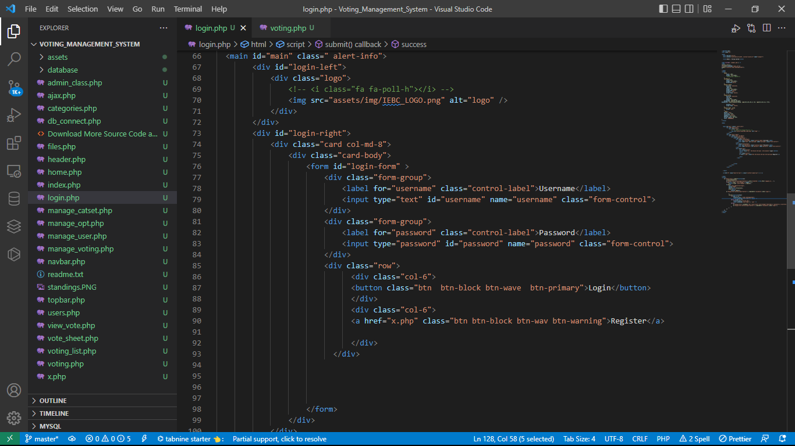

If a voter or user is not registered, they first use the register button which takes them to registration page. Once they register, they can now log in.

### 4.3.2 Admin Dashboard

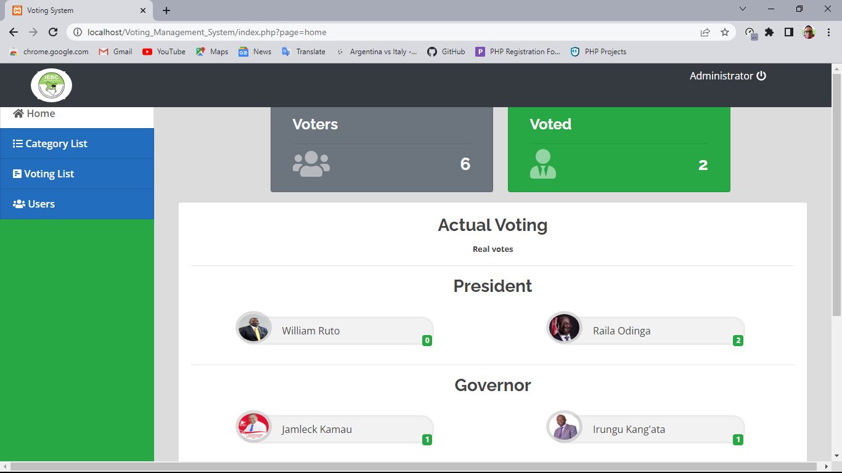

Only the Admin and RO can view the tally of votes and they do immediately they log in to the system.

### 4.3.3 Voter Dashboard

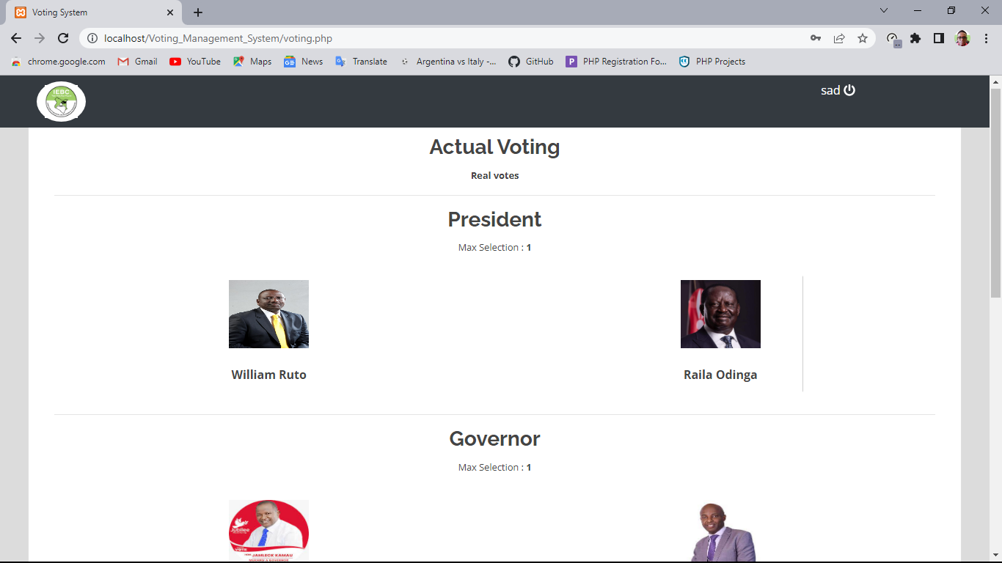

When a new voter registers, when they log in, they are directed to the voting page where they can vote for or select only one candidate per category or elective seat.

### 4.4 Coding Details and Code Efficiency

JavaScript and HTML code have been integrated into PHP files where they fall on the same webpage for code efficiency.

AJAX framework has bee used to optimize and seamlessly connect the frontend to the backend.

### 4.5 Testing

### 4.5.1 Unit Testing

The system has four modules: registration module, voting module, administrator module and vote tallying module.

Each of these modules was tested separately and the necessary changes made to ensure they all work harmoniously.

### 4.5.2 Integration Testing

After the development of individual modules, they were all integrated together to form one working system.

### 4.5.3 Usability Testing

A working prototype of the complete system was rolled out to some voters to see the capabilities of the system. They found the system easy to interact with and user-friendly interface used.

# Chapter Five: Results and Discussion

### 5.1 Test Report

The system has reasonable short time response. The voter can login or sign up is able to get response for his request in 2-4 seconds which is robust compared to earlier system. All the password that are generated or accepted is stored in database in an encrypted compared to existing system where it may be stored as it is thus vulnerable to attacks. Successful application is done only if user uploads correct filled form and the administration checks for details to verify whether the applicant is qualified to be a registered voter or not. In voting and tallying the system is reliable, providing high performance. To prevent data loss in case of system failure, the filled form is saved in the database waiting for approval or for future refences.

**5.2 User Documentation**

### 5.2.1 Interface

When the voter logs in this platform using any browser, below interface appears:

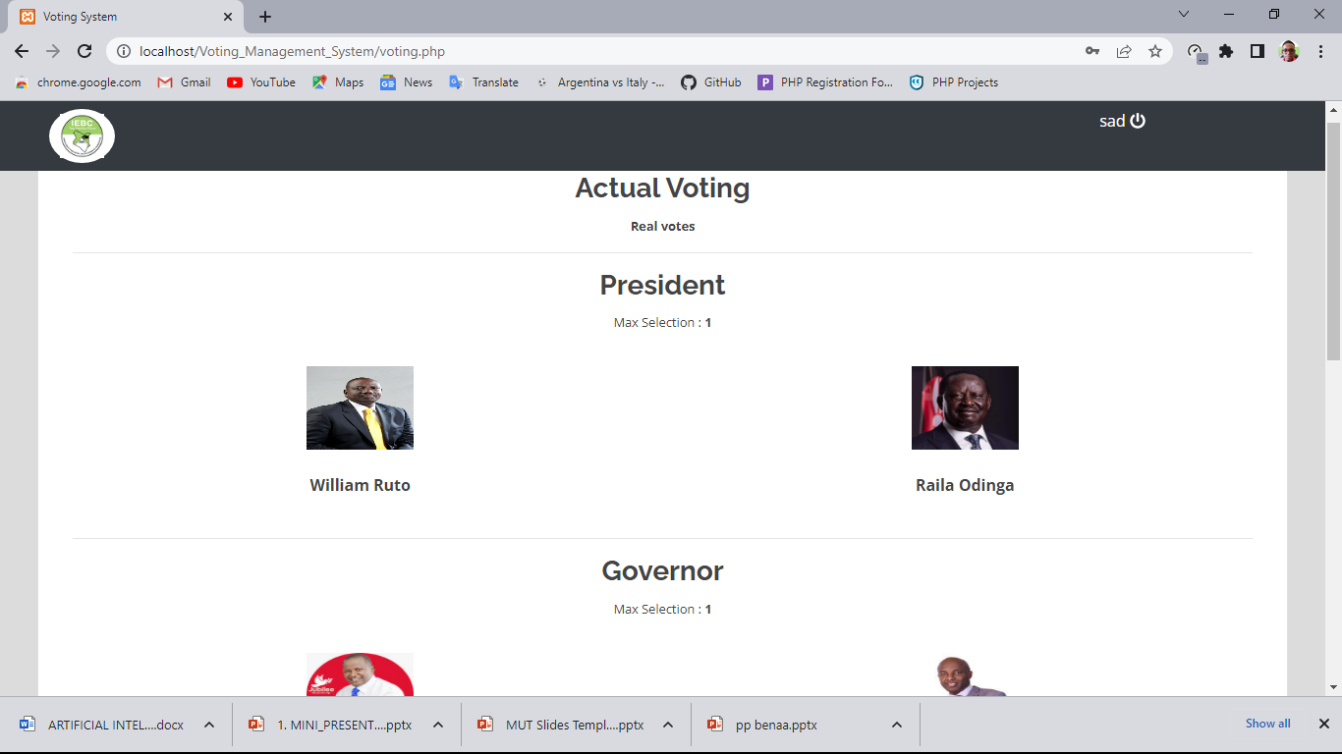

The voter is just required to vote and wait for the results to be announced later.

The voter registration page looks like this:

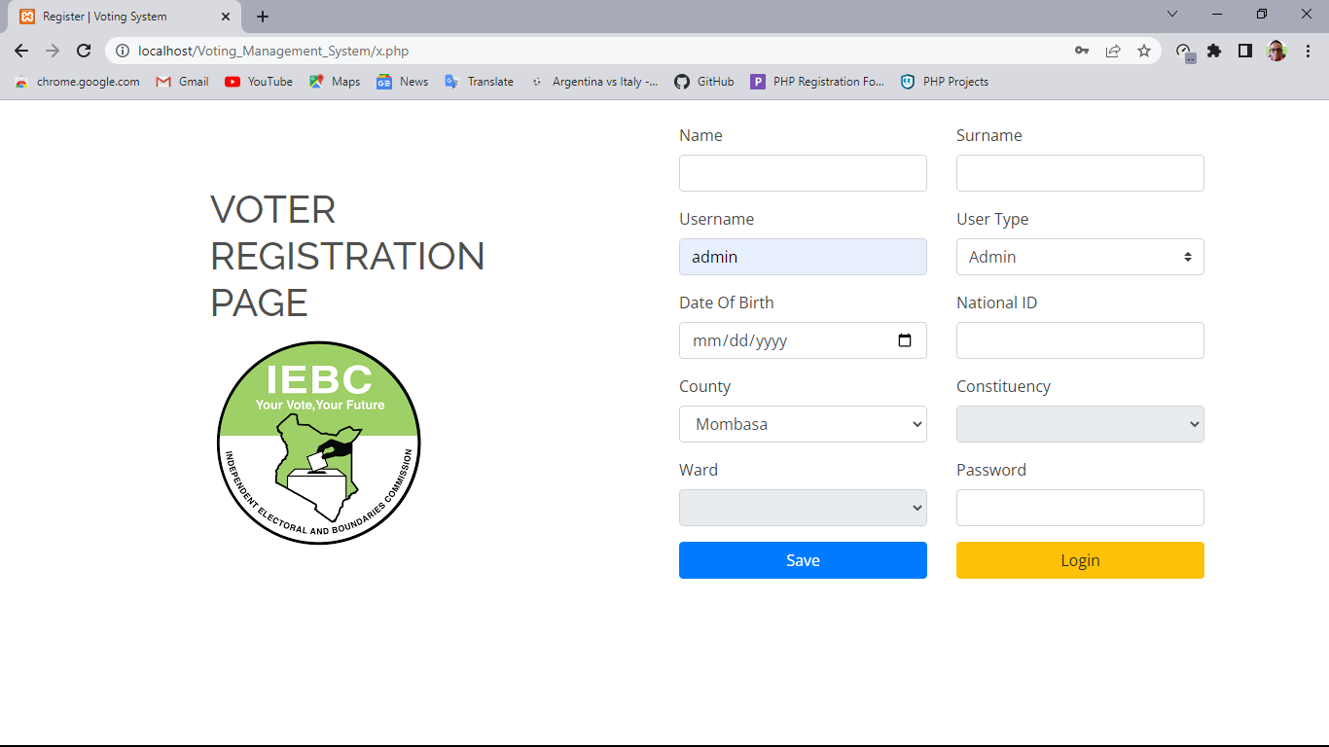

This is where a new voter inputs all their personal details which are then saved in the database.

### Chapter Six: Conclusions

### 6.1 Summary of The Findings

The findings of the research show that indeed there are many disadvantages with the current approach used to register new voters, which would be solved with the functionalities of this system. For instance;

The lengthy paperwork required currently by the IEBC in voter registration which is quite tedious. It is not necessary to subject these people to such processes notwithstanding the fact that time is a very delicate factor in this process. The proposed system only requires you to provide your details and then you can start voting immediately from your mobile phone or computer.

Once a voter does vote using their account, they cannot vote again using the same account.

### 6.2 Conclusions and Future Works

Time is a very important resource as well as a very delicate factor especially when it comes to delivery of public services. Voter registration and voting together with vote tallying are not exempted from this factor. The traditional method of voter registration and voting is fraught with difficulties and uncertainties due to the manual approach used to oversee the process. As a result of this, not only is money is lost through ghost channels but also a lot of time is wasted. There arises a need therefore for a system that will address these challenges while emphasizing on efficiency and accountability. Such a system is the one that has been discussed in this document with the hope that all the current loopholes in this matter of voter registration and voting will be fixed.

### 6.3 Recommendation.

A lot of improvements can be done on the current version of the system. These include but no limited to:

The system can be adapted to suit all kinds of platforms; including android versions for staff workers involved in registering voters who cannot register themselves instead of having to open the browsers every time.

The solutions expressed in this system can be used in any other national exercise of the same magnitude as the one discussed above for more efficiency in the delivery of this and other services.

# References

Abutabenjeh, S., & Jaradat, R. (2018). Clarification of research design, research methods, and research methodology: A guide for public administration researchers and practitioners. Teaching Public Administration, 36(3), 237-258.

Testing Expert Advisor. (n.d.). Retrieved from Charm Forex:

http://www.charmforex.com/index.php?pg=testing-expert-advisor

Walton, M. (2010, May 22). Forex Candlesticks. Retrieved from Marc Walton forex trading

academy: http://forextrainingacademy.com/forex-training/week1/forex-

Nery, M., Neto, C., Rosado, A., & Smith, P. K. (2019). Bullying in youth sport training: A nationwide exploratory and descriptive research in Portugal. European Journal of Developmental Psychology, 16(4), 447-463.

# APPENDICES

## Appendix I: Grantt Chart

|  |  |  |  |  |  |  |  |  |  |  |  |  |  |  |
| --- | --- | --- | --- | --- | --- | --- | --- | --- | --- | --- | --- | --- | --- | --- |
| **Stage/ Week** | 1 | 2 | 3 | 4 | 5 | 6 | 7 | 8 | 9 | 10 | 11 | 12 | 13 | 14 |
| Requirement Analysis |  |  |  |  |  |  |  |  |  |  |  |  |  |  |
| System Design |  |  |  |  |  |  |  |  |  |  |  |  |  |  |
| Implementation |  |  |  |  |  |  |  |  |  |  |  |  |  |  |
| Testing |  |  |  |  |  |  |  |  |  |  |  |  |  |  |
| Deployment |  |  |  |  |  |  |  |  |  |  |  |  |  |  |
| Maintenance |  |  |  |  |  |  |  |  |  |  |  |  |  |  |

## Appendix II: Budget

|  |  |  |
| --- | --- | --- |
| **Stage** | **Description** | **Amount** |
| Requirement Analysis |  | K Sh 3,000 |
| System Design | On paper and Prototype | K Sh 4,500 |
| Implementation |  | K Sh 5,200 |
| Testing | In-house and Participant testing | K Sh 2,500 |
| Deployment |  | K Sh 4,100 |
| Maintenance | Over first 3 months | K Sh 6,000 |
| **TOTALS** |  | **K Sh 25,300** |